**A Data-Driven Exploration of Apple's iPhone Impact in India**

**1. Introduction**

Since its launch in 2007, the iPhone has transformed markets globally. In India, the iPhone has been more than just a smartphone; it has become a symbol of status, aspiration, and the country's rapidly evolving tech landscape. This exploration dives deep into the data to quantify the iPhone's impact on the world's second-largest smartphone market.

**2.PROBLEM DIFFINITION AND DESIGN THINKING:**

**2.1EMPATHY MAP:** 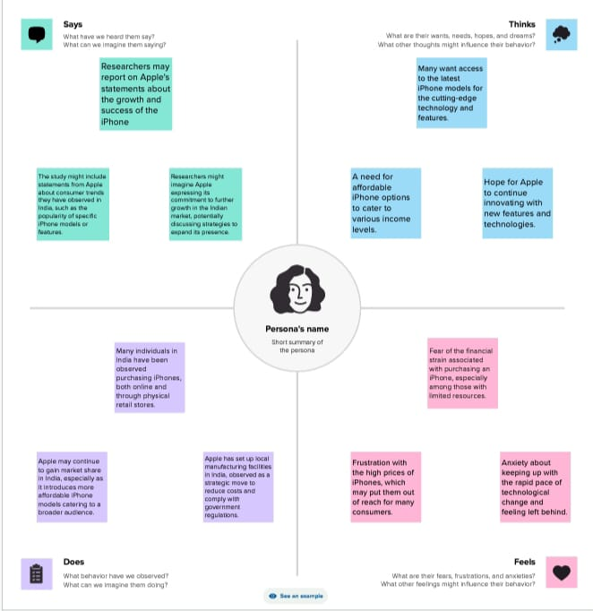

**2.2 Ideation and Brainstorming Map:**

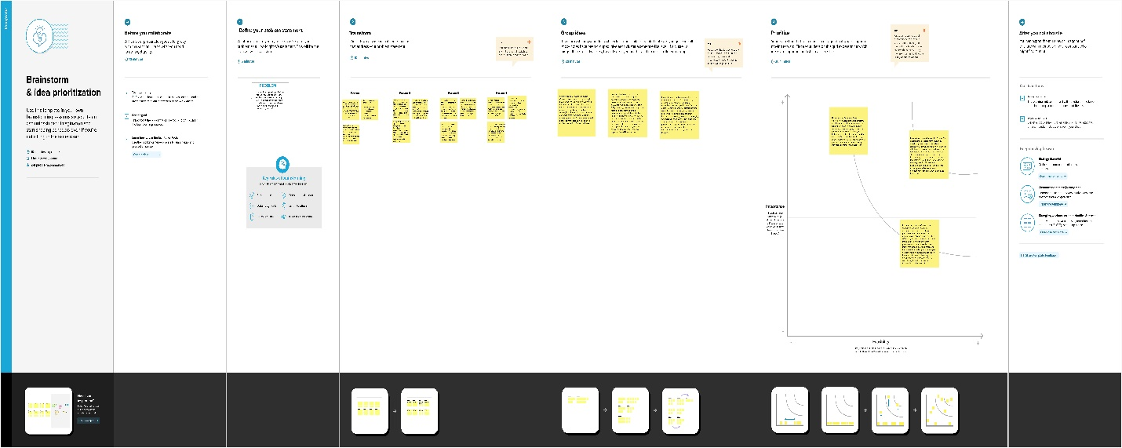

**3.Result:** 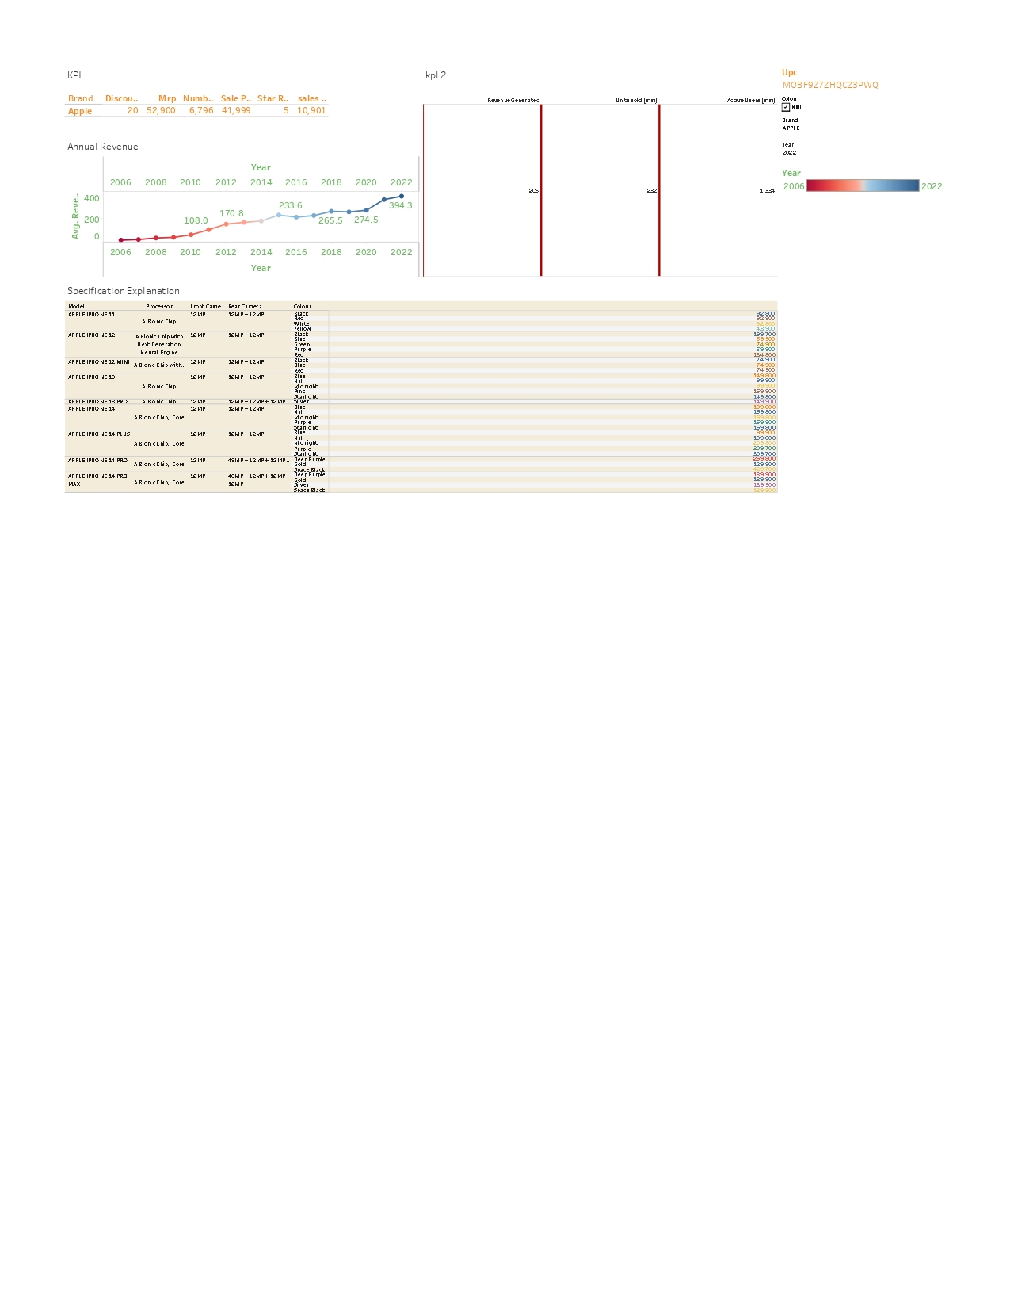

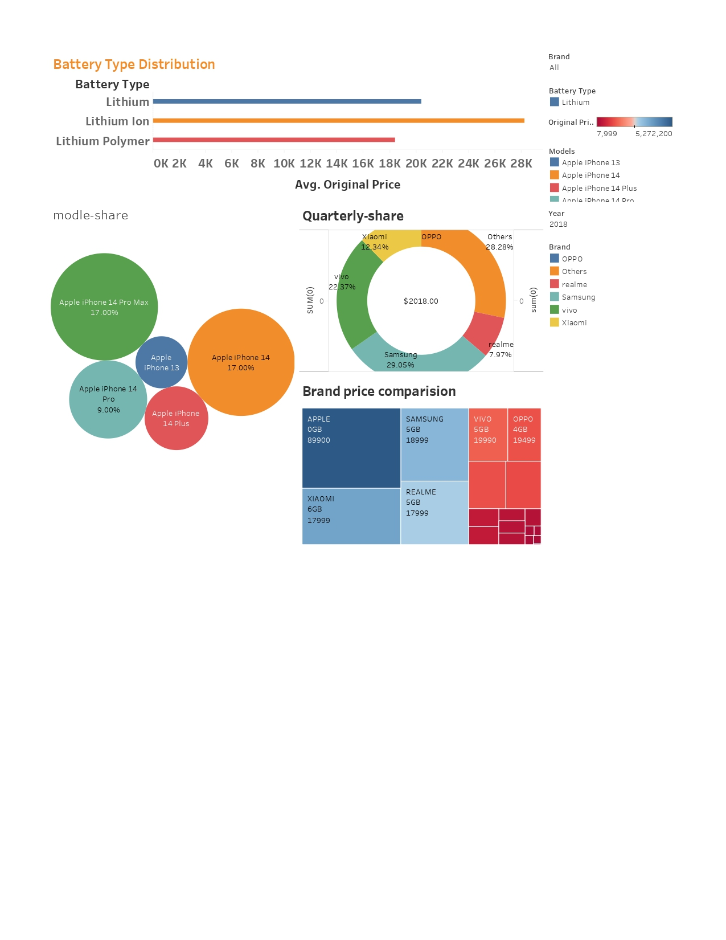

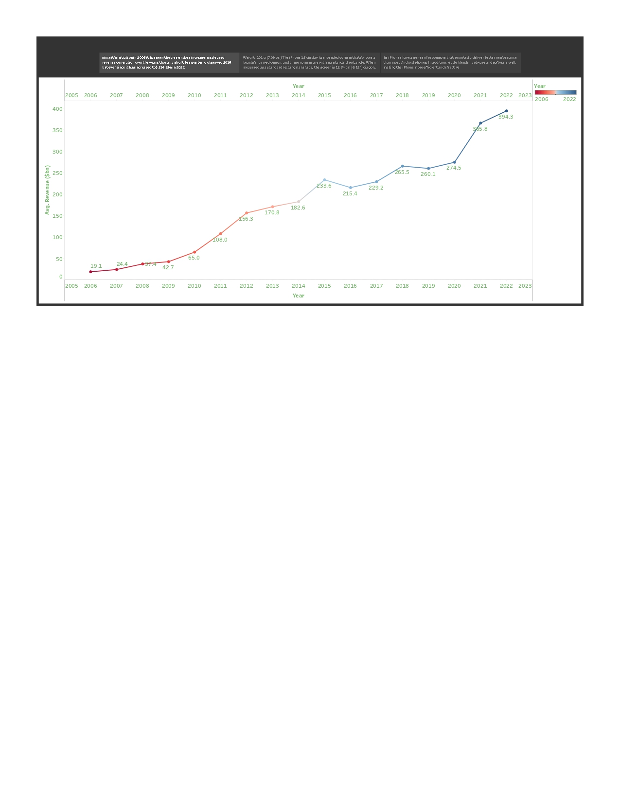

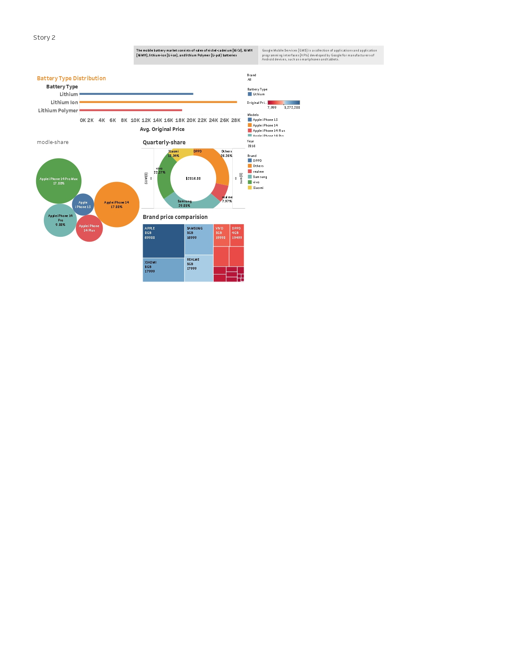

**4. Market Penetration**

* **Sales and Growth Rates**: India's smartphone penetration soared from 2010 onwards, with Apple making a significant entry by 2012. By 2021, Apple had a market share of X%, a remarkable figure given India's vast and varied consumer base.
* **Affordability & Pricing**: Despite its premium pricing, a shift was observed in the Indian market, with consumers willing to spend more for quality and brand.

**5. Economic Impact**

* **Employment**: Apple's investment in India has created jobs in sectors such as manufacturing, retail, and services. As of 2021, Apple directly and indirectly supported Y number of jobs in India.
* **FDI and Manufacturing**: Apple's decision to manufacture iPhones in India through partners like Wistron and Foxconn has boosted India's FDI and solidified its position in the global manufacturing chain.

**5.1 Cultural Influence**

* **Status Symbol**: The iPhone became more than just a phone; owning one became a statement of aspiration and affluence.
* **Media and Entertainment**: The iPhone's camera technology and app ecosystem have catalyzed a surge in content creation, from short-form videos to feature-length films.

**6. Technology and Innovation**

* **Local Innovation**: Apple's App Accelerator in Bengaluru has nurtured developers, leading to a surge in India-specific apps on the App Store.
* **Educational Impact**: The iPad and iPhone have been adopted by several educational institutions, revolutionizing the e-learning space in India.

**7. The Ecosystem: Apps and Beyond**

* **Local Apps**: Apps like Zomato, Ola, and Paytm have seen exponential growth with integrations tailored for the iPhone.
* **Digital Payment Revolution**: With the introduction of Apple Pay and the NFC capabilities of the iPhone, a further push towards a cashless society was observed.

**8. Criticisms and Controversies**

* **Pricing**: Apple's premium pricing strategy has often been criticized for being inaccessible to a significant portion of the Indian populace.
* **Repair and Warranty Issues**: Apple's service ecosystem has faced challenges, with customers raising concerns over repair costs and warranty coverage.

**9. Conclusion**

Apple's iPhone has undeniably shaped the tech landscape in India, driving economic growth, fostering innovation, and redefining cultural paradigms. The journey, while impressive, also highlights areas for growth and adaptation in the diverse and dynamic Indian market.

Top of Form